Industrial Practical Training-1
Report
On
Power BI Dashboard: Superstore Dataset
SUBJECT CODE-IPT-301-P
Submitted
In the partial fulfilment
For the award of the degree of
Bachelor of Technology
In
Computer Science & Engineering

Submitted To: Submitted By:
Dr. SUNITA RANI Tanisha Palmia (23013057)
ASSOCIATE PROFESSOR B. Tech CSE 5th Sem


DEPARTMENT OF COMPUTER SCIENCE AND ENGINEERING & INFORMATION TECHNOLOGY
BHAGAT PHOOL SINGH MAHILA VISHWAVIDYALAYA, KHANPUR KALAN

DECLARATION

I hereby declare that the Industrial Training Report on project entitled “Power BI Dashboard: Superstore Dataset” submitted in partial fulfilment of the requirements for Bachelor of Technology in Computer Science and Engineering is my original work, completed during my Industrial Training in Data Analysis domain at SICT, Faridabad.

This project is a result of my own efforts, with guidance and support acknowledged and have adhered to all academic and ethical guidelines in the completion of this project.

All sources of information, data and help have been duly acknowledged
ACKNOWLEDGEMENT

I express my sincere gratitude to the Standard Institute of Computer Technology (SICT) for providing me the opportunity to undertake this project as part of my training in the Data Analysis domain. I am deeply thankful to Mr. Mukesh, Director of SICT, for his continuous guidance, encouragement, and for creating a learning environment that enabled me to enhance my technical skills.
I would also like to extend my heartfelt thanks to Mr. Deepak, Head of Training at SICT, for his valuable support, insightful feedback, and mentorship throughout the duration of my project. His direction has been instrumental in helping me understand practical aspects of data analysis.
I am grateful to my university, Bhagat Phool Singh Mahila Vishwavidyalaya (BPSMV), for including industrial training as a part of the curriculum, which has significantly contributed to my academic and professional development.
Finally, I thank my peers, mentors, and everyone who directly or indirectly supported me during the completion of this project.

- Declaration (i)
- Acknowledgement (ii)
- Certificate (iii)
- Abstract (iv)
- Introduction of Organisation (v)

S.No. | CONTENT
1 | INTRODUCTION
2 | DATASET DESCRIPTION
3 | WORKFLOW
4 | PYTHON IMPLEMENTATION
5 | SQL IMPLEMENTATION
6 | POWER BI DASHBOARD
7 | TECHNOLOGIES EXPLANATION
8 | CONCLUSION
9 | FUTURE SCOPE
10 | REFERENCES

Introduction of Organisation

The Standard Institute of Computer Technology (SICT) is a well-established professional training institute recognized for its commitment to delivering high-quality technical education and industry-driven skill development. With a strong focus on practical learning, SICT has built a reputation for preparing students to meet the evolving needs of the IT and analytics industry. The institute offers a wide range of certification and internship programs in areas such as Data Analysis, Python Programming, Business Intelligence, Database Management, Web Development, and Machine Learning.

SICT is known for its experienced trainers, structured curriculum, and modern learning environment, which includes hands-on labs, real-time case studies, and continuous performance evaluation. The institute emphasizes application-based learning, ensuring that students not only understand theoretical concepts but also gain practical exposure through real-world projects and industry datasets.

I completed my three-month training and internship in the Data Analysis domain at SICT, where I worked extensively on data cleaning, data preprocessing, visualization techniques, and dashboard development. The program exposed me to essential tools like Python, Pandas, NumPy, SQL, and Power BI, enabling me to understand end-to-end data workflows—from data extraction to generating business insights.

The internship environment encouraged critical thinking, teamwork, and problem-solving, helping me develop confidence in handling real datasets and building analytical solutions. My experience at SICT not only strengthened my technical foundation but also enhanced my ability to interpret data, communicate insights, and approach business problems with a structured analytical mindset.

Abstract

This industrial training project focuses on developing an end-to-end data analytics solution using the Superstore dataset by integrating Python, SQL, and Power BI. The primary objective of the project was to clean, structure, analyze, and visualize retail sales data to extract meaningful insights that can support business decision-making. The project began with data loading and preprocessing in Python, where various data cleaning operations were performed, including handling missing values, removing duplicates, correcting data types, and performing feature engineering such as extracting year, month, and calculating profit ratios. After preparing the cleaned dataset, it was exported and stored into a MySQL database to enable structured querying and efficient data management.

SQL queries were then used to explore and aggregate the dataset to answer key business questions related to sales performance, profitability, customer segments, product categories, and regional trends. Finally, an interactive dashboard was developed in Power BI using DAX measures such as Total Sales, Total Profit, Profit Margin, Average Discount, and Quantity Sold to visually communicate insights.

The project demonstrates a complete workflow commonly used in real-world analytics environments—data cleaning, database management, querying, and visualization. It not only enhanced my technical skills in Python, SQL, and Power BI but also improved my ability to interpret business trends and present data-driven insights. Overall, this project highlights the importance of analytics in improving business performance and supporting informed decision-making.

1.Introduction
I completed a 3-month Industrial Training in the domain of Data Analysis, where I gained hands-on experience with real-world datasets and analytics tools. The primary objective of this training was to understand how data is collected, cleaned, analysed, and visualized to support decision-making in an organization.
The training helped me understand industry practices such as writing optimized SQL queries, performing data cleaning and feature engineering in Python, and creating business-focused dashboards in Power BI. I also learned how to interpret metrics like sales trends, profit patterns, customer segments, and product performance.
Overall, the training strengthened my technical skills, improved my analytical thinking, and prepared me to handle data-driven projects with a structured approach. The project I completed reflects the full data analysis lifecycle—from data extraction to visualization—and demonstrates my ability to apply tools and techniques used widely in the industry.

1.1 Objectives of the Project
- To understand the complete data analysis lifecycle — including data collection, cleaning, transformation, analysis, and visualization.
- To import and manage the Superstore dataset using SQL, enabling efficient storage, retrieval, and query-based analysis.
- To perform data cleaning and preprocessing using Python to ensure data accuracy, consistency, and readiness for analysis.
- To conduct Exploratory Data Analysis (EDA) for identifying trends, patterns, and anomalies in sales, profit, customers, and regional performance.
- To build interactive dashboards in Power BI to visually represent key business metrics and support data-driven decision making.
- To analyse sales performance across categories, regions, and customer segments for deriving actionable insights.
- To apply statistical and analytical techniques to evaluate business performance and understand factors affecting profitability.
- To integrate SQL, Python, and Power BI tools in a single end-to-end workflow to simulate real-world data analytics environments.
- To develop the ability to translate raw data into meaningful insights and business recommendations.
- To improve technical and analytical skills required for real industry projects in the field of Data Analytics.

1.2Tools & Technologies Used
- Python
- Power BI
- MySQL
- Jupyter Notebook
2.Dataset Description
2.1About the Superstore Dataset
The Superstore Dataset is a widely used sample dataset in the field of data analytics and business intelligence. It represents the sales operations of a fictional retail company that sells office supplies, furniture, and technology products across different regions. The dataset contains detailed transactional data, making it ideal for practicing data cleaning, analysis, and dashboard creation.
The dataset includes information on orders, sales, customers, shipments, and product details, allowing analysts to study business performance from multiple perspectives. It is commonly used in analytics training, Power BI/Tableau projects, and machine learning experiments because of its rich structure and real-world relevance.
2.2Key Features of the Superstore Dataset
- Order Detail:
Includes Order ID, Order Date, Ship Date, Ship Mode, and Customer ID.
- Customer Information:
Contains Customer Name, Segment, and Region, helping analyze customer behavior and sales distribution.
- Product Details:
Provides Product ID, Category, Sub-Category, and Product Name.
- Sales & Profit Metrics:
Includes Sales, Quantity, Discount, and Profit values for each order line.
- Geographical Dimensions:
Contains Region, State, and City fields enabling geographical analysis.
- Shipment Information:
Helps understand delivery time, shipping mode performance, and logistics.
For this project, the dataset was obtained in CSV format, which was then imported into MySQL, processed using Python (Pandas), and visualized in Power BI. The dataset is clean, well-structured, and ideal for performing end-to-end data analysis workflows.

3.Workflow

4.Python Implementation (Data Cleaning & Processing)
4.1Loading Data Using Pandas
To begin the analysis, the Superstore dataset was loaded into the Python environment using the Pandas library, which is widely used for data manipulation and analysis. Pandas provides efficient data structures such as DataFrames, making it easy to read, explore, clean, and transform datasets.
Explanation
- import pandas as pd imports the Pandas library.
- read_csv() reads the dataset from a CSV file and loads it into a DataFrame.
- df.head() displays the first five rows to confirm successful loading and understand the structure of the data.
Purpose of Loading Data with Pandas
- Enables efficient data cleaning and preprocessing
- Facilitates exploratory data analysis (EDA)
- Allows transformation of data prior to exporting to SQL or Power BI
- Helps identify missing values, incorrect formats, and inconsistencies early in the process
4.2. Data cleaning
- Checked for missing values and duplicates
- Converted incorrect data types
- Cleaned inconsistent strings and categories
- Removed data entry errors and outliers
- Extracted useful date-based features
- Fixed encoding errors
- Exported the final cleaned dataset for SQL and Power BI analysis
4.3. Exporting Cleaned Data to MySQL
- 1.Import Required Libraries
- 2. Load the Cleaned Dataset
- 3. Create a MySQL Engine (Connection String): A connection is established using SQL Alchemy’s create_engine() method.
- 4. Export DataFrame to MySQL

5.SQL Implementation (Data Analysis)
1.Database Creation
2. Table Creation
3. Data Insertion (Python → MySQL)
4. SQL Queries for Data Analysis
To analyse business performance, several SQL queries were executed.
Below are the major insights derived using SQL.

4.1 Sales by Year
SELECT YEAR(Order_Date) AS Year, SUM(Sales) AS Total_Sales
FROM superstore
GROUP BY YEAR(Order_Date)
ORDER BY Year;

4.2 Profit by Sub-Category
SELECT Sub_Category, SUM(Profit) AS Total_Profit
FROM superstore
GROUP BY Sub_Category
ORDER BY Total_Profit DESC;

4.3 Sales by Category
SELECT Category, SUM(Sales) AS Total_Sales
FROM superstore
GROUP BY Category;

4.4 Top 10 Customers by Sales
SELECT Customer_Name, SUM(Sales) AS Customer_Sales
FROM superstore
GROUP BY Customer_Name
ORDER BY Customer_Sales DESC;
4.5 Profit by Segment
SELECT Segment, SUM(Profit) AS Segment_Profit
FROM superstore
GROUP BY Segment;

4.6 Yearly Profit Trend
SELECT YEAR(Order_Date) AS Year, SUM(Profit) AS Total_Profit
FROM superstore
GROUP BY YEAR(Order_Date)
ORDER BY Year;

6.Power BI Dashboard
Import CSV into Power BI
- Home → Get Data → Text/CSV → choose superstore_cleaned_for_powerbi.csv.
- Use Power Query to change types, create calculated columns, date hierarchies.
- Build visuals.
Measures Used in the Dashboard (DAX / Power BI Measures)
Core Aggregation Measures
Total Sales = SUM(Orders[Sales])
Total Quantity = SUM(Orders[Quantity])
Total Profit = SUM(Orders[Profit])
Total Discount = SUM(Orders[Discount])
Key KPIs
1. Total Profit: 286.40K
Shows overall business profitability.
2. Total Sales: 2.30M
Represents overall revenue generated.
3. Total Quantity Sold: 38K
Indicates customer demand.
4. Total Discount Offered: 1.56K
Shows how much revenue was reduced through discounts.

Detailed Analysis
A. Profit by Sub-Category
- Copiers → Highest profit
- Phones and Accessories also contribute strongly
- Some categories show negative/low profit → needs pricing optimization
This helps identify which product lines perform well.

B. Sales by Year
Shows growth trend from 2014 to 2017:
- Slight drop in 2015
- Strong rise in 2016 & 2017 (0.27M)
This indicates improving business performance every year.

C. Sales by Category
- Furniture (36.4%)
- Technology (31.3%)
- Office Supplies (32%)
Good distribution across categories, showing balanced product demand.

D. Top 10 Customers by Sales
Zuschuss Carroll, Yana Sorenson, William Brown are top buyers.
This helps in customer segmentation and targeted marketing.

E. Profit by Segment
- Consumer: Highest profit
- Corporate: Moderate
- Home Office: Lowest
Useful for understanding customer segment profitability.

F. Profit Trend by Year
Shows fluctuations in profit month-wise across years.
- Peaks at 9K
- Some negative profit months due to discounts or low sales
This helps analyze seasonal performance.

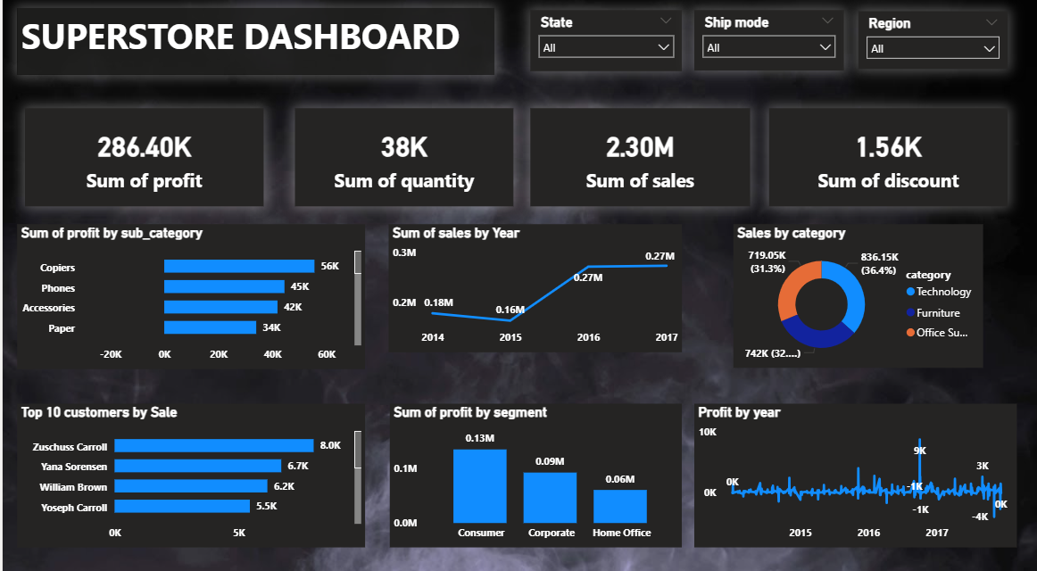
POWER BI DASHBOARD

7.Technologies Explanation
7.1What is MySQL?
MySQL is an open-source Relational Database Management System (RDBMS) that uses SQL (Structured Query Language) to store, organize, and manage data. It is one of the most widely used databases worldwide due to its speed, reliability, and ability to handle large datasets efficiently.
MySQL allows users to create tables, insert data, run queries, perform aggregations, and maintain data integrity—all within a structured and secure environment.
Because of its scalability and performance, MySQL is commonly used in data analytics, web applications, business intelligence, and enterprise-level systems.

Why MySQL is Used in Our Project
MySQL played an important role in the Superstore Sales Analysis project. After cleaning and preparing the dataset in Python, MySQL was used for the following reasons:
- Structured Data Storage:
MySQL helps store the cleaned Superstore dataset in an organized, table-based format, making it easy to manage and analyze.
- Efficient Query Execution:
SQL queries in MySQL were used to calculate key metrics such as:
  - Total Sales
  - Total Profit
  - Average Discount
  - Category-wise performance
  - Region-wise analysis
MySQL can handle these operations faster than Excel or Python loops.
- Better Data Integrity:
Storing data in MySQL ensures consistency, prevents duplication, and maintains a clean, validated version of the dataset.
- Integration with Python:
The cleaned data from Pandas was sent to MySQL using Python libraries like SQLAlchemy or PyMySQL, making the workflow seamless.
- Easy Connection with Power BI:
Power BI connects directly to MySQL, allowing dashboards to be refreshed automatically using the stored data.
- Real-World Industry Practice:
In real organizations, data is usually stored in databases like MySQL. Using MySQL in the project reflects industry-level analytics workflows.
7.2 What is Python?
Python is a high-level, general-purpose programming language known for its simplicity, readability, and versatility. It is widely used in data analysis, machine learning, automation, web development, and scientific computing.
Python provides powerful libraries such as Pandas, NumPy, Matplotlib, Scikit-learn, and many more that help process, analyze, and visualize data efficiently.
Its easy syntax and strong community support make it one of the most preferred languages for beginners and professionals in the field of data analytics and data science.

Why Python is Used in Our Project
Python was used in the Superstore Sales Analysis project for several important reasons:
- Data Cleaning and Preprocessing:
Python’s Pandas library allows efficient handling of large datasets. We used it to remove duplicates, handle missing values, correct data types, and perform feature engineering.
- Feature Engineering:
Columns such as Order Year, Month, Profit Margin, and Discount Impact were created using simple Python operations, which helped in deeper analysis.
- Flexibility and Automation:
Python scripts make the data processing workflow repeatable and fully automated compared to manual Excel cleaning.
- Exporting Data to SQL:
Python was used to load the cleaned dataset into a MySQL database using libraries like SQLAlchemy and PyMySQL. This helps maintain a smooth connection between raw data, cleaned data, and database storage.
- Handling Large Files Easily:
Python can efficiently process thousands of rows, making it much more powerful and faster than manual tools.
- Industry-Standard for Data Analysis:
Using Python aligns with how real organizations prepare and transform data before it is sent to BI tools like Power BI.
- Integration With Power BI and SQL:
Python acts as a bridge between raw data → cleaned data → SQL database → Power BI dashboard

7.3 What is Pandas?
Pandas is a powerful open-source Python library used for data manipulation, analysis, and cleaning. It provides flexible and easy-to-use data structures such as DataFrames and Series, which allow users to handle structured data efficiently.
Pandas makes it possible to load, clean, filter, group, reshape, and analyze datasets with just a few lines of code.
Because of its speed, simplicity, and Excel-like functionality, Pandas has become one of the most widely used libraries in data analytics and data science.

Why Pandas is Used in Our Project
Pandas played a crucial role in the Superstore Sales Analysis project. It was used for the following purposes:
- Loading the Dataset:
We used Pandas to import the Superstore CSV file into a DataFrame for analysis.
- Data Cleaning:
Pandas helped perform essential cleaning tasks such as:
  - Removing duplicates
  - Handling missing values
  - Fixing incorrect data types
  - Removing extra spaces and special characters
- Feature Engineering:
New analytical columns were created using Pandas, such as:
  - Order Year
  - Order Month
  - Profit Margin
  - Discount Effect
  - Sales Categories
- Filtering and Transformations:
Pandas was used to filter rows, group data, sort values, and reshape data for SQL and Power BI.
- Preparing Data for MySQL:
After cleaning, the final DataFrame was exported from Pandas into a MySQL database using Python connectors, ensuring the data was structured and ready for SQL queries.
.
7.4 What is Power BI?
Power BI is a powerful Business Intelligence (BI) and data visualization tool developed by Microsoft. It allows users to connect to various data sources, clean and transform data, create interactive dashboards, and generate meaningful insights through charts, graphs, and reports.
Power BI provides an intuitive drag-and-drop interface, making it easy to design visuals without complex coding. It also supports advanced analytics using DAX (Data Analysis Expressions) for creating custom measures and KPIs.

Why Power BI is Used in Our Project
Power BI was used in the Superstore Sales Analysis project because it helps convert cleaned and processed data into clear, interactive visual insights. It played a key role for the following reasons:
- Interactive Dashboards:
Power BI enabled us to create dashboards showing key metrics such as:
  - Total Sales
  - Total Profit
  - Profit Margin
  - Quantity Sold
  - Average Discount
  - Category & Sub-Category performance
  - Region-wise sales trends
- Better Visualization:
Power BI converts complex datasets into easy-to-understand charts like bar charts, line charts, maps, and pie charts, making insights visual and impactful.
- Easy Integration with MySQL:
Power BI can directly connect to the MySQL database, allowing real-time or scheduled data refreshes.
- DAX Measures for Advanced Analysis:
Custom calculations such as Profit Margin, YoY Growth, and Discount % were created in Power BI using DAX to enhance analysis.
- Filtering and Drill-Down:
Slicers and filters allow users to explore data by segment, region, category, and more—making it highly interactive.
- Professional Reporting:
Power BI dashboards look professional and are easy to present, making them ideal for project work, internships, and industry use.

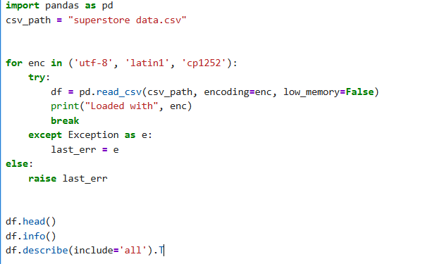
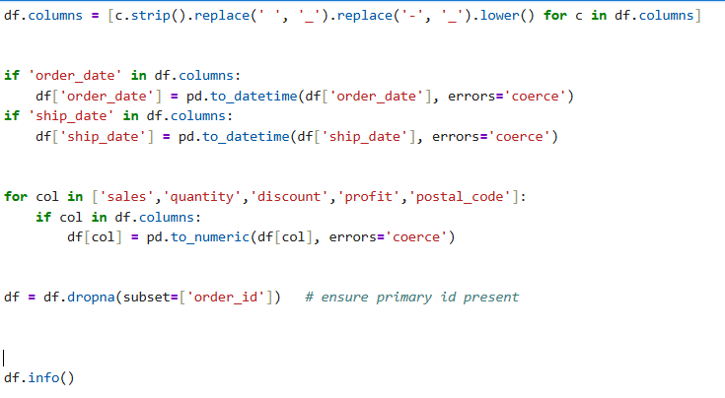
Python code for reading dataset
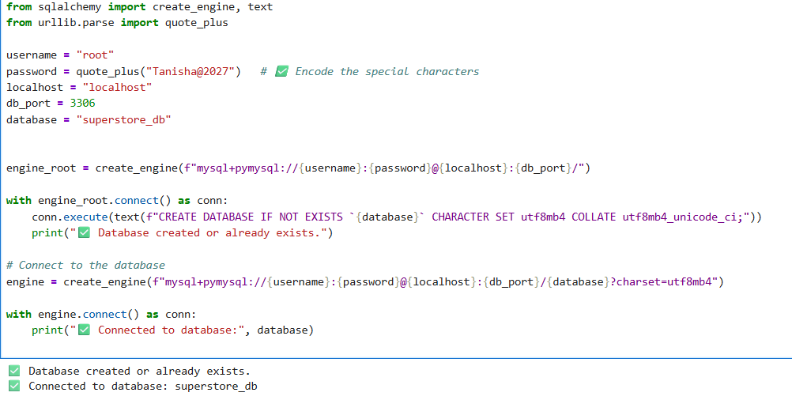

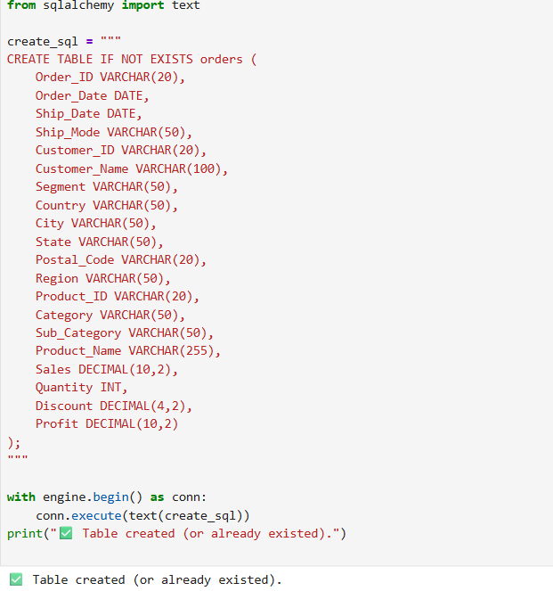
Table View of PowerBI
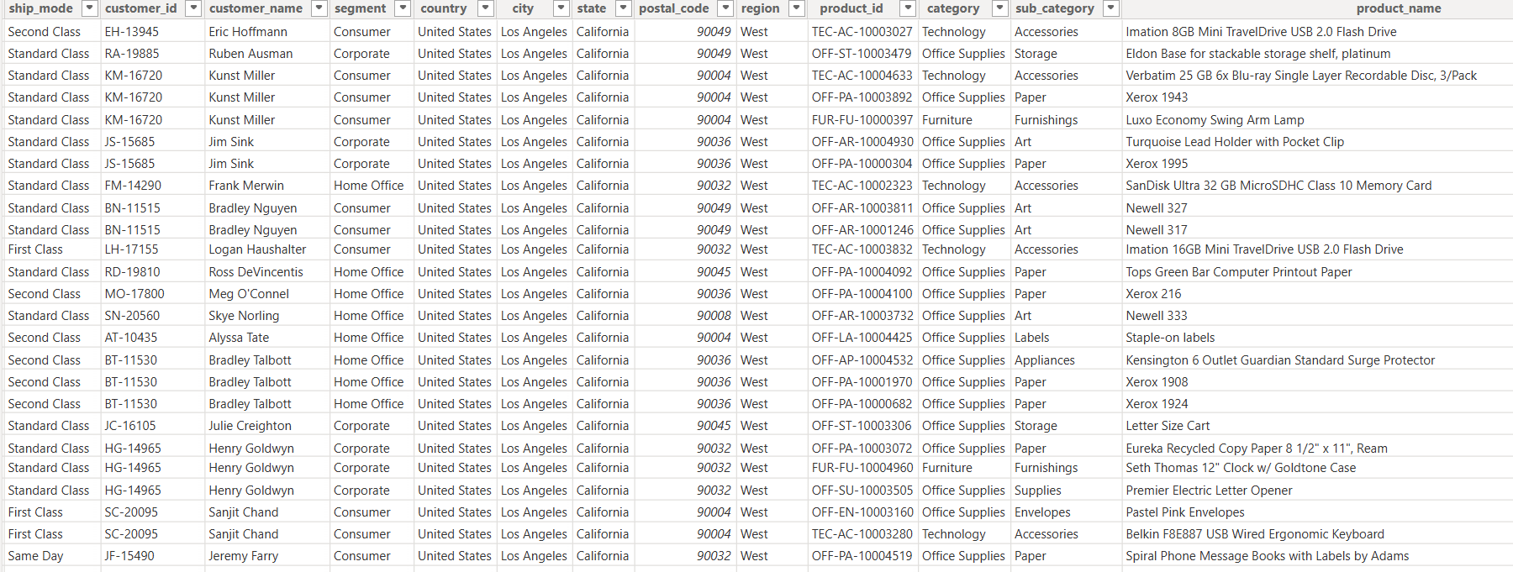
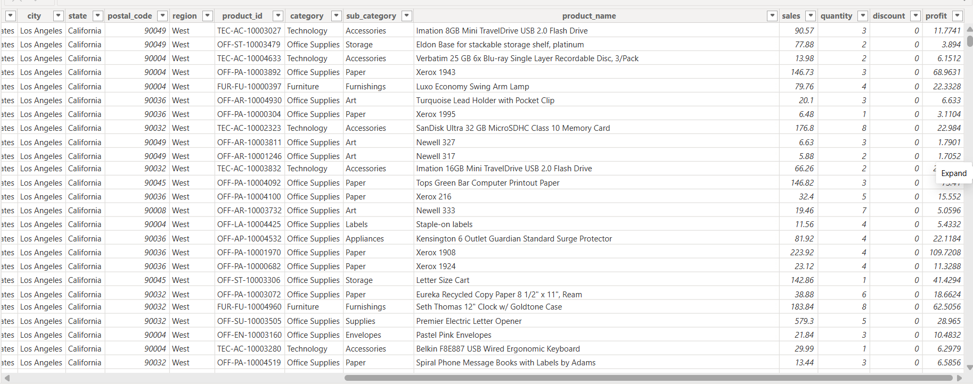
Model View of PowerBI
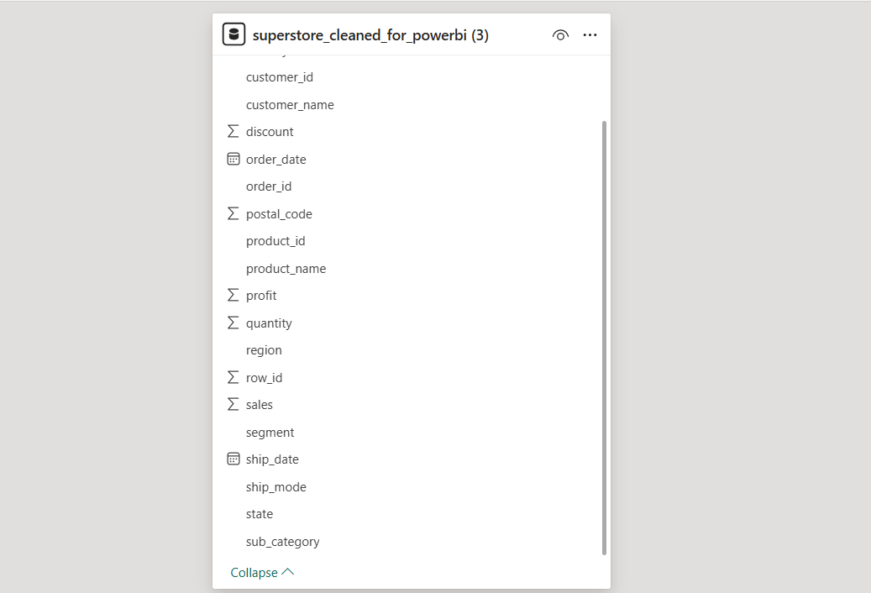
8.Conclusion
The industrial training project on Superstore Sales Analysis successfully demonstrated the complete data analytics lifecycle using Python, SQL, and Power BI. Starting from data collection and cleaning, followed by feature engineering and database creation, to dashboard development and insight generation, each step contributed to building a fully functional business intelligence solution.
The project enhanced my technical ability to manipulate real-world datasets and convert them into meaningful insights that support decision-making.

What Business Problem the Superstore Dataset Helps Solve

The Superstore dataset helps in solving key retail business problems such as:

- Identifying high and low-performing products

- Understanding regional sales variations

- Finding areas where profits are declining

- Detecting the impact of discounts on profit margins

- Understanding customer purchasing behavior

- Recognizing shipping and delivery patterns

By analyzing these aspects, businesses can address profitability issues, optimize resources, and reduce losses.

Why Analysis Is Needed

Retail companies generate huge volumes of data every day, but raw data alone cannot support business decisions. Analysis is needed to:

- Clean and organize data for accuracy

- Discover hidden trends and patterns

- Understand the relationship between sales, profit, category, region, and discount

- Identify strengths and weaknesses in the business

- Support planning, forecasting, and strategy formulation

Without proper analysis, decision-makers may rely on assumptions rather than data-driven insights.

What Decisions Your Analysis Supports

The insights generated from your SQL–Python–Power BI analysis can help the business make several important decisions:

- Product & Inventory Decisions

- Which products should be stocked more?
- Which categories/sub-categories are unprofitable?
- What items need price adjustments?

2. Sales & Marketing Decisions

- Which regions need targeted promotions?
- Which customer segments bring the most revenue?
- What discount strategies maximize sales without losing profit?

3. Operational Decisions

- Which shipping modes are most efficient?
- How can delivery timelines be optimized?

4.Strategic Decisions

- Where to expand or reduce operations?
- Long-term planning based on sales trends

8.1 Summary
This project focuses on performing an end-to-end data analysis of the Superstore dataset using Python, MySQL, and Power BI. The goal was to understand sales performance, profitability, customer behavior, and regional trends to support data-driven decision-making. The project began by loading and cleaning the dataset using Python, where operations such as handling missing values, removing duplicates, correcting data types, and performing feature engineering were carried out using Pandas. The cleaned dataset was then exported into a MySQL database for structured storage and efficient querying.
Using SQL, various analytical queries were executed to calculate important business metrics such as Total Sales, Total Profit, Average Discount, Quantity Sold, and category- and region-wise performance. The insights from these queries provided a deeper understanding of the business data and highlighted key trends and problem areas.
Finally, Power BI was used to design an interactive and visually appealing dashboard. DAX measures were created to compute KPIs, and charts such as bar graphs, line charts, maps, and category comparisons were used to visually communicate findings.
The project successfully demonstrates a complete data analytics workflow—from data cleaning and preparation to database management, analytical querying, and dashboard creation. It strengthened my technical skills in Python, SQL, and Power BI, and provided valuable insights into real-world business analytics practices.

The major tasks completed were:
- Data cleaning & preprocessing using Python (handling missing values, correcting data types, feature engineering).
- Database creation and query execution in MySQL for structured data storage and analysis.
- Writing SQL queries for KPI calculation, filtering, grouping, and joining data.
- Exporting clean data to MySQL from Python.
- Building interactive dashboards in Power BI with measures such as Total Sales, Profit, Quantity Sold, Average Discount, Profit Margin, etc.
- Creating visualizations including bar charts, line charts, maps, category analysis, and subcategory comparisons.
The project delivered a complete end-to-end analytics workflow, similar to what is used in real companies.

8.2What I Learnt
During this project, I gained hands-on experience in:
Technical Skills
- Using Python (Pandas, NumPy) for data cleaning, processing, and exporting
.
- Implementing feature engineering such as extracting order year/month, computing profit ratio, discount impact, etc.

- Working with MySQL:
  - Creating tables
  - Writing complex SQL queries
  - Handling joins, aggregations, and conditions
- Designing Power BI dashboards:
  - Creating DAX measures
  - Building KPIs
  - Using slicers, filters, and drill-downs
  - Creating interactive visuals

Analytical Skills
- Understanding business KPIs like sales performance, profitability, and customer segmentation.
- Performing trend analysis and operational insights.
- Converting raw business data into insights useful for decision-makers.

Professional Skills
- Documentation and report writing
- Presentation of data analytics results
- Time management during project execution

Project Usefulness
This project is extremely useful from both a business and career perspective:
Business Usefulness
- Helps businesses analyze their sales and profit trends.
- Identifies top-performing and underperforming categories.
- Supports regional sales planning and forecasting.
- Enables companies to make data-driven decisions on:
  - Discounts
  - Inventory planning
  - Customer segmentation strategies
Career Usefulness
- Demonstrates end-to-end Data Analyst workflow.
- Adds strong practical experience in:
  - Python
  - SQL
  - Power BI
- Shows your ability to work with real datasets and generate insights.
- Enhances your resume and helps in internships/placements for Data Analyst and Business Analyst roles.

9.Future Scope

The Superstore Sales Analysis project offers significant potential for further development and enhancement. While the current analysis provides valuable insights into sales, profit trends, and customer behaviour, several future improvements can make the system more robust and business-ready.

- Advanced Predictive Analytics:
Machine learning algorithms such as regression models, time-series forecasting (ARIMA, Prophet), or classification models can be applied to predict future sales, profit trends, customer lifetime value (CLV), and product demand.

- Automation of Data Pipeline:

The entire workflow—from data extraction to cleaning, loading into MySQL, and updating dashboards—can be automated using tools like Airflow, Cron Jobs, or Python scripts to ensure real-time or scheduled updates.

- Real-Time Data Integration:
Instead of static CSV data, the project can be extended to connect with live databases, APIs, or ERP systems to provide real-time business insights.

- Enhanced Power BI Dashboards:
The dashboards can be expanded to include AI visuals, forecasting visuals, drill-through pages, and alerts for threshold-based KPIs to support strategic decision-making.

- Deployment on Cloud Platforms:
The project can be migrated to cloud services like AWS, Azure, or Google Cloud for scalability, better storage, higher performance, and remote access to dashboards.

- Incorporation of Additional Datasets:
Integrating customer demographic data, marketing data, or supply chain data could enable deeper analysis such as customer segmentation, inventory optimization, and pricing strategies.
Overall, these enhancements can turn the project into a fully automated, intelligent business analytics system capable of supporting large-scale organizational decisions.

10.References

- Kaggle. Superstore Dataset.
Available at: https://www.kaggle.com/

- Microsoft Power BI Documentation. Guide to Power BI Desktop and Service.
Available at: https://learn.microsoft.com/power-bi/

- GeeksforGeeks.
SQL, Python, Pandas, and Data Visualization Tutorials.
Available at: https://www.geeksforgeeks.org/

- Jupyter Notebook Documentation.
Interactive Computing Environment for Python.
Available at: https://jupyter.org/documentation

- IBM Data Analyst Professional Certificate (Coursera).
Modules on SQL, Python, Data Visualization & BI Tools.

